OT-Med Map Template

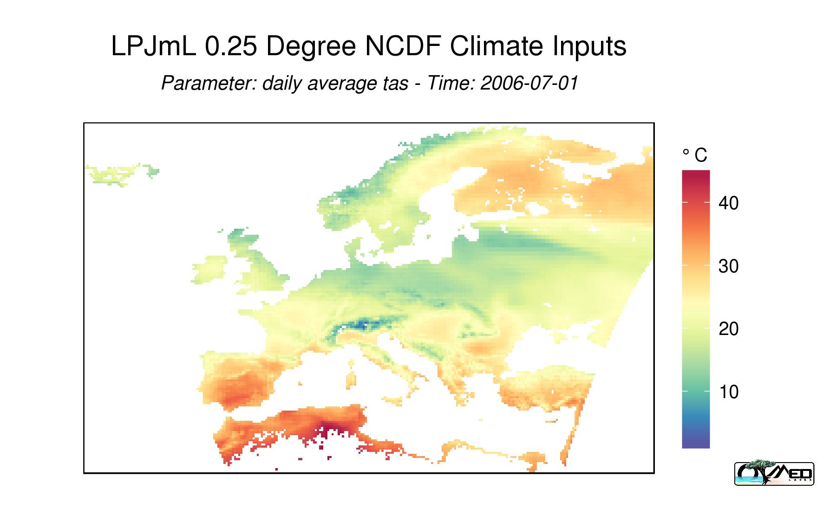

- Original raster data from NCDF

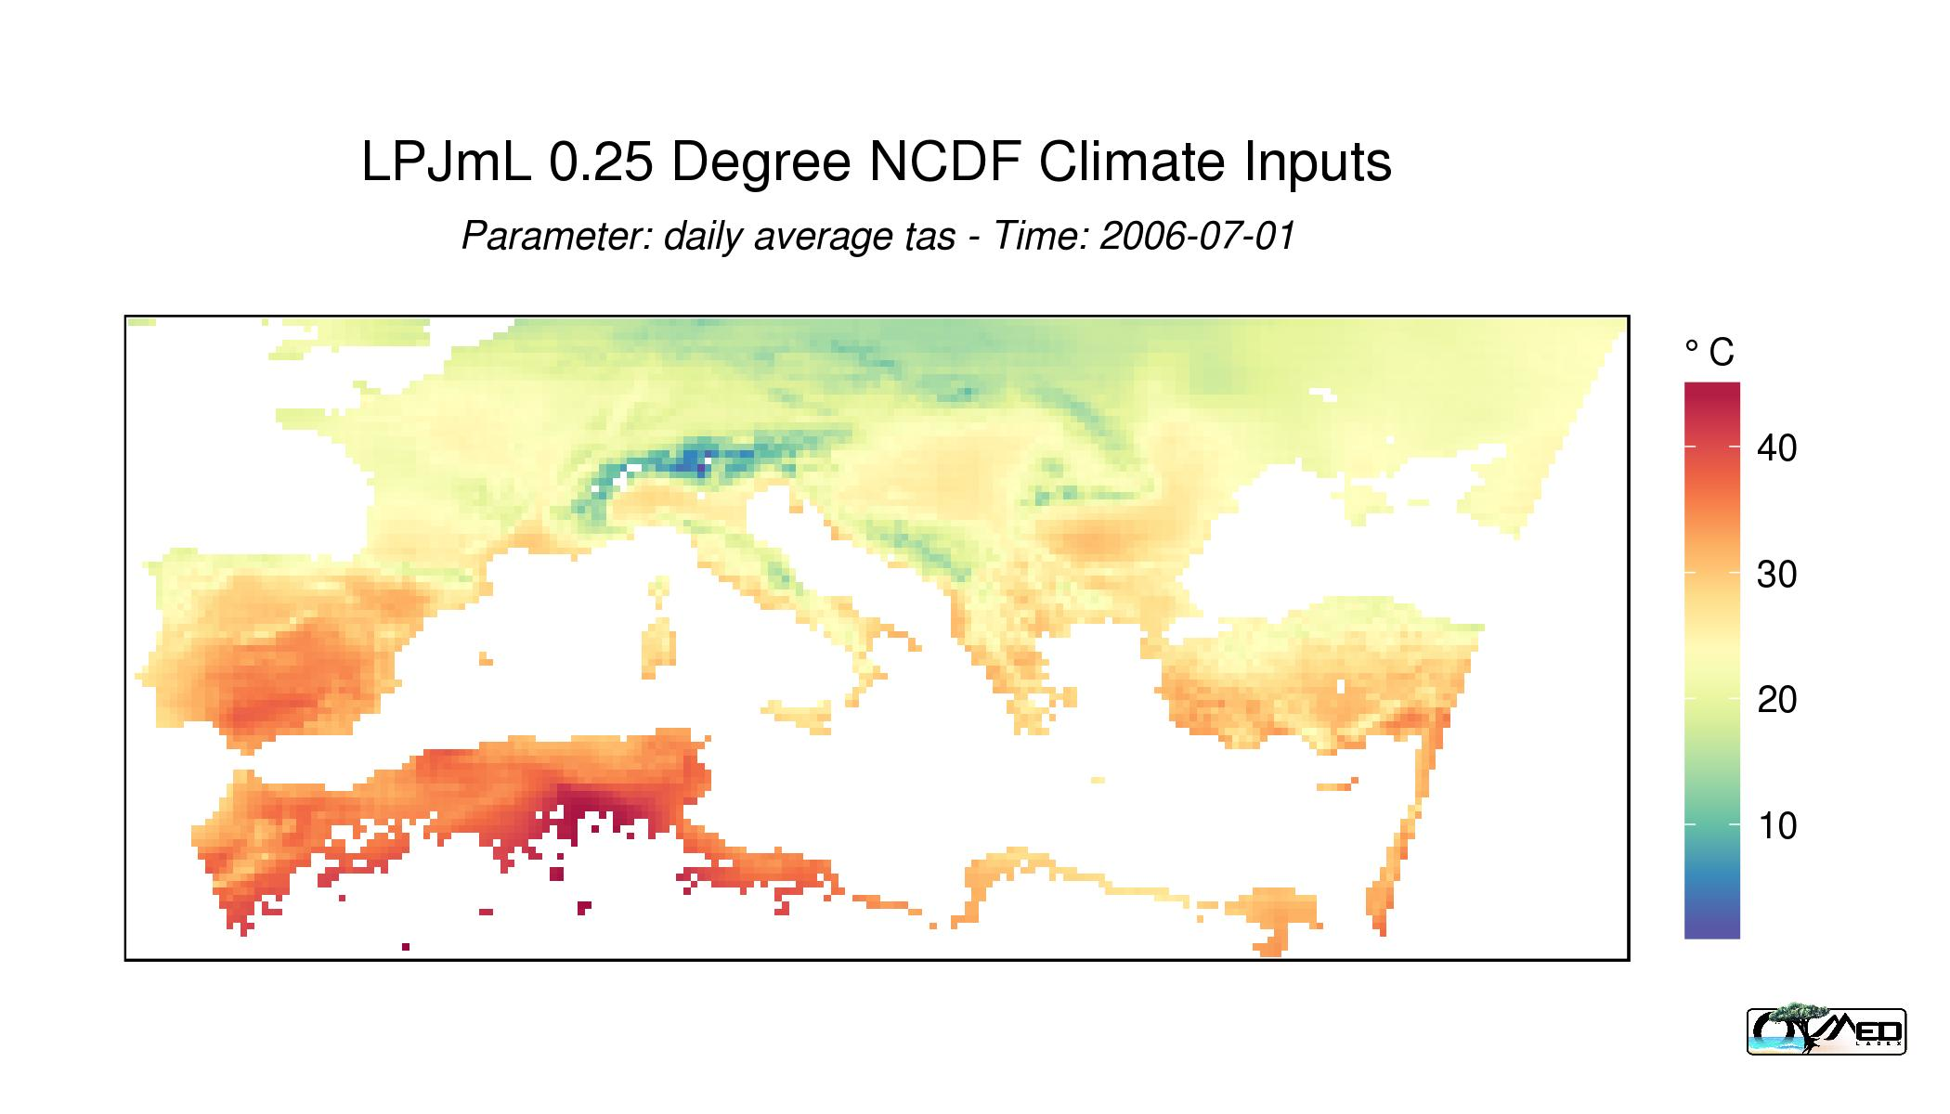

- Cut data into a window by a user specified boundary

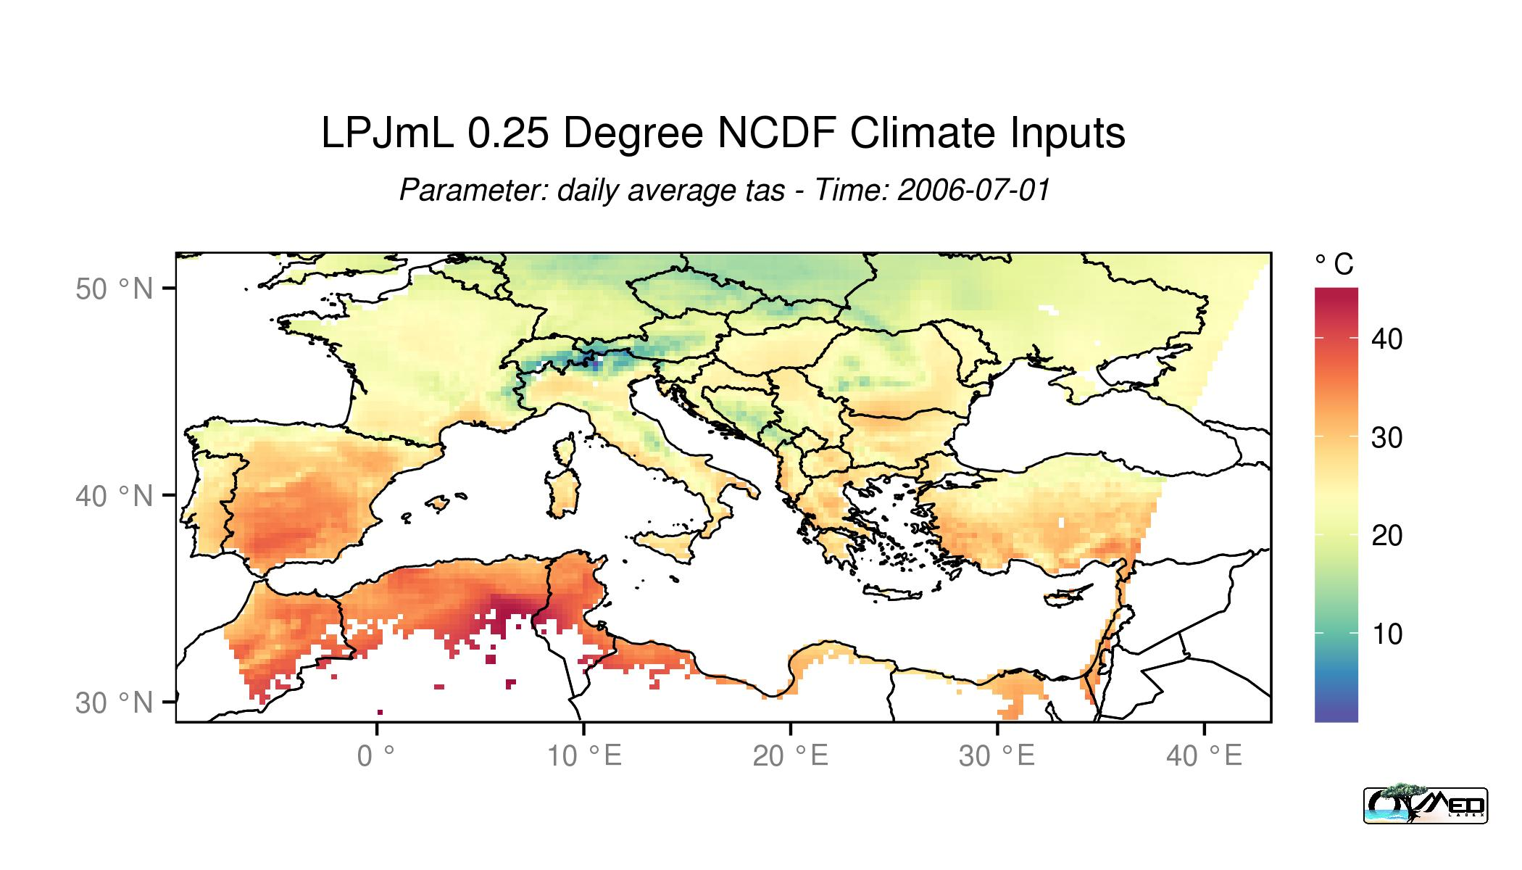

- addLines(): This function allows user to put lines from ESRI shape files. The template has integrated 5 different types of polygon data, including country lines, coastlines, rivers, lakes and islands, all in 3 resolution 10 min, 50 min, 110 min.
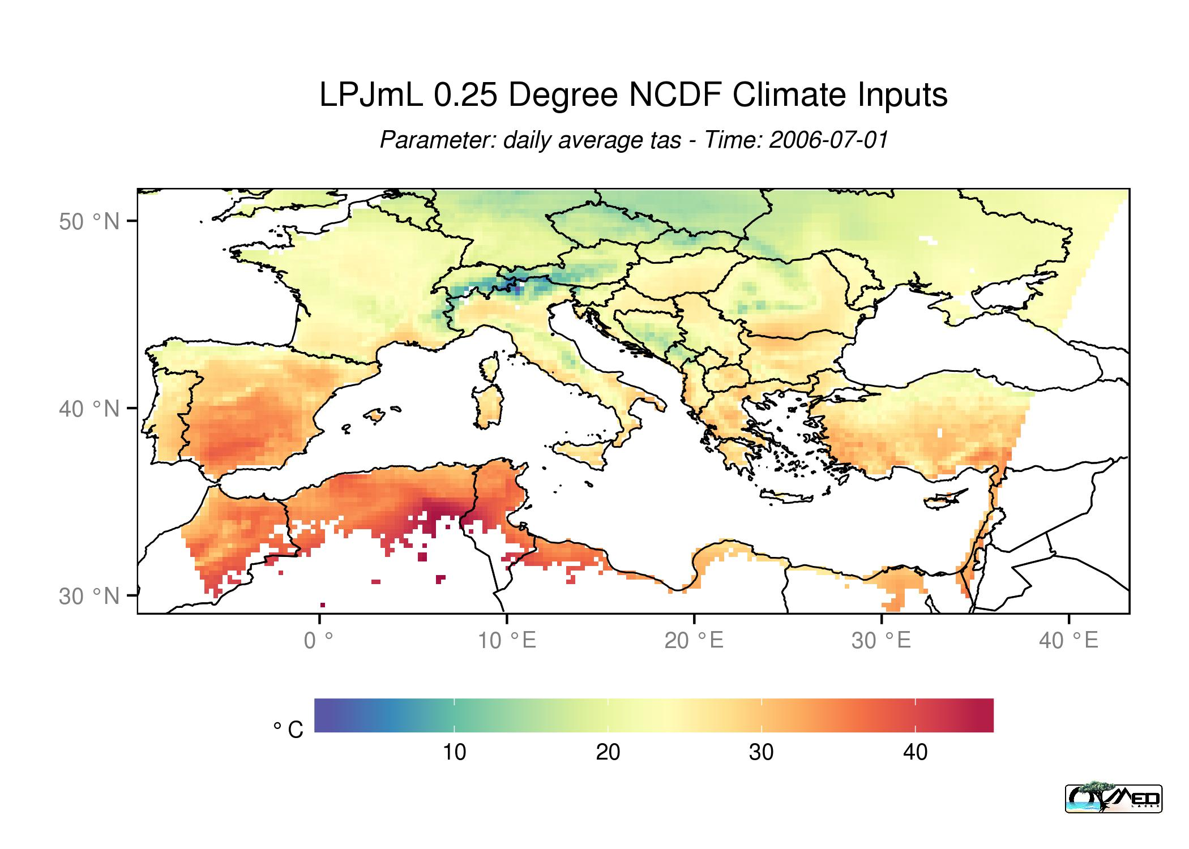
- Moving legend position are much easier than before, only by specifying the position such as top, bottom, left and right

- mapProjection: this function allows user to convert rasters and polygons, lines and points into any specified projection by specifying proj4 strings.
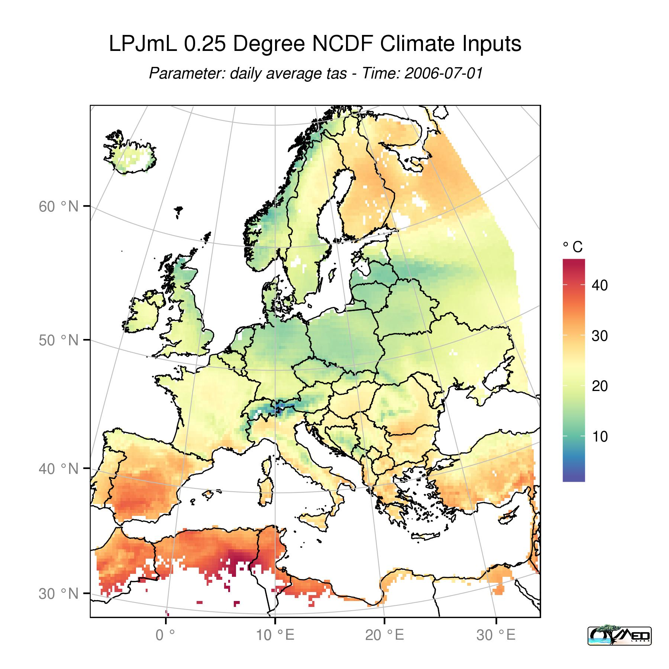

- 20 pre-prepared standard colour scales
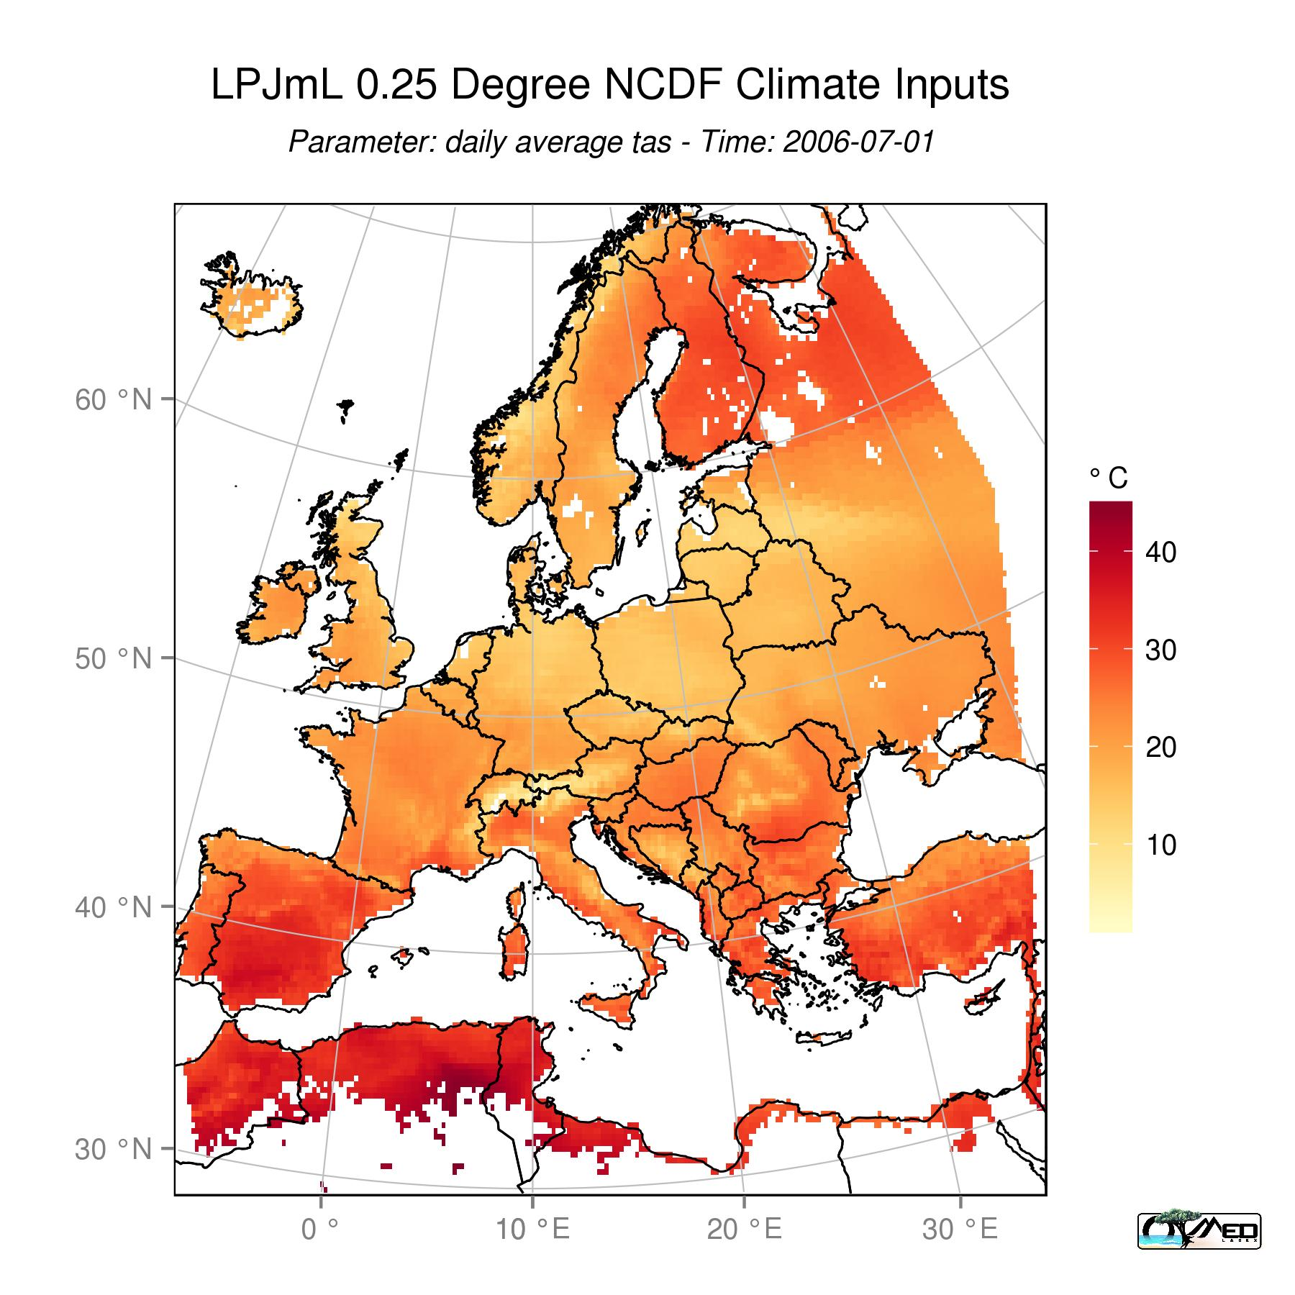 | 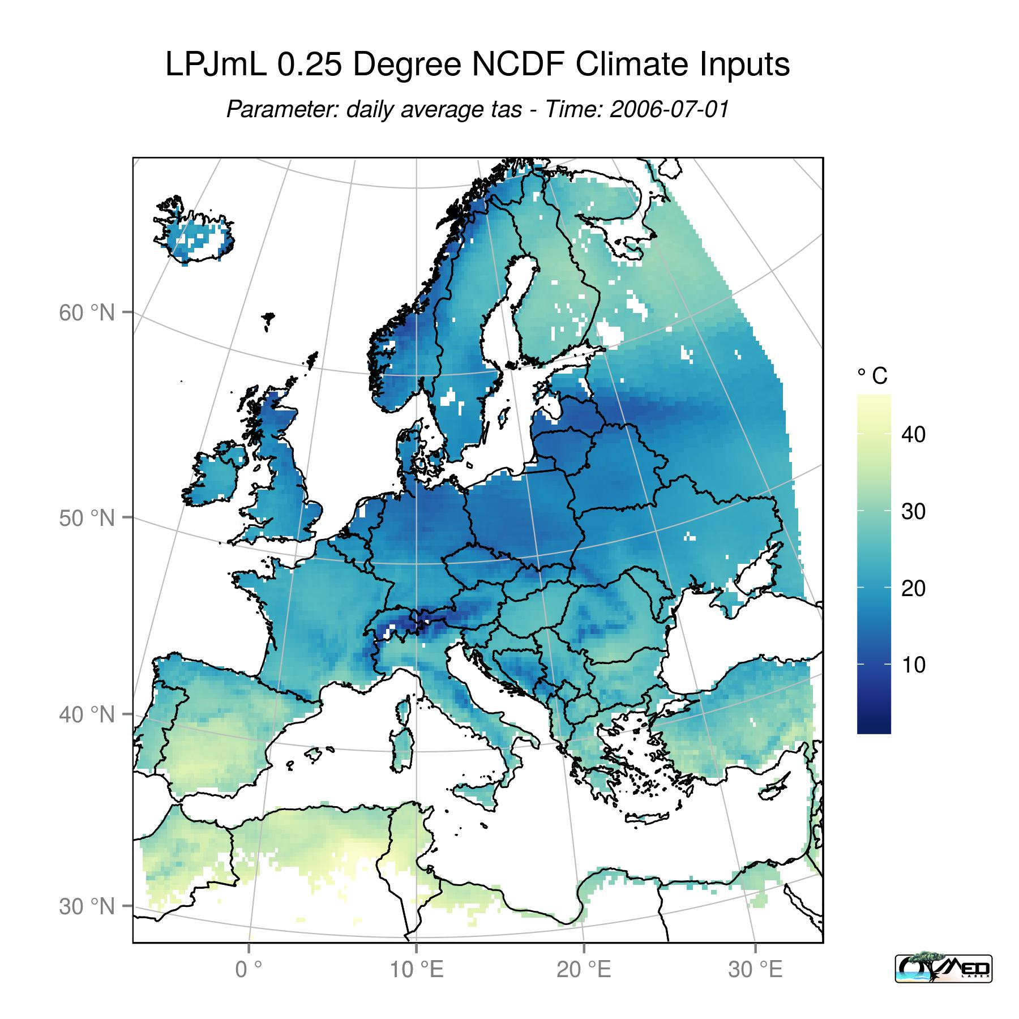 | 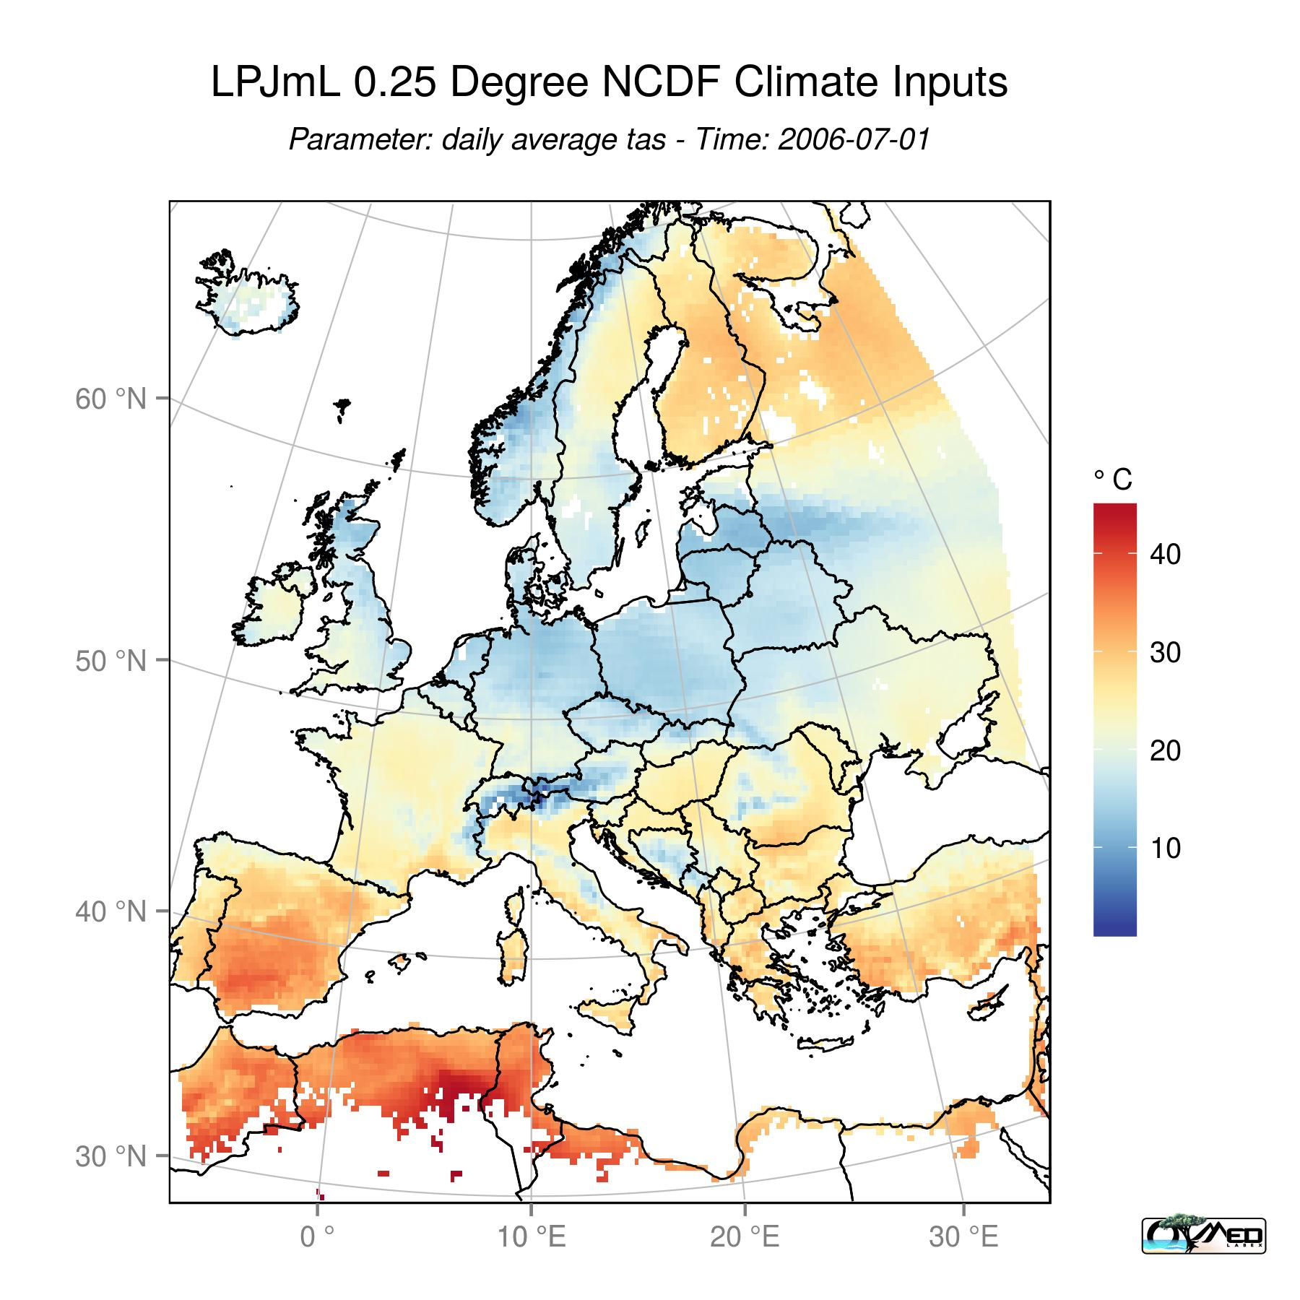

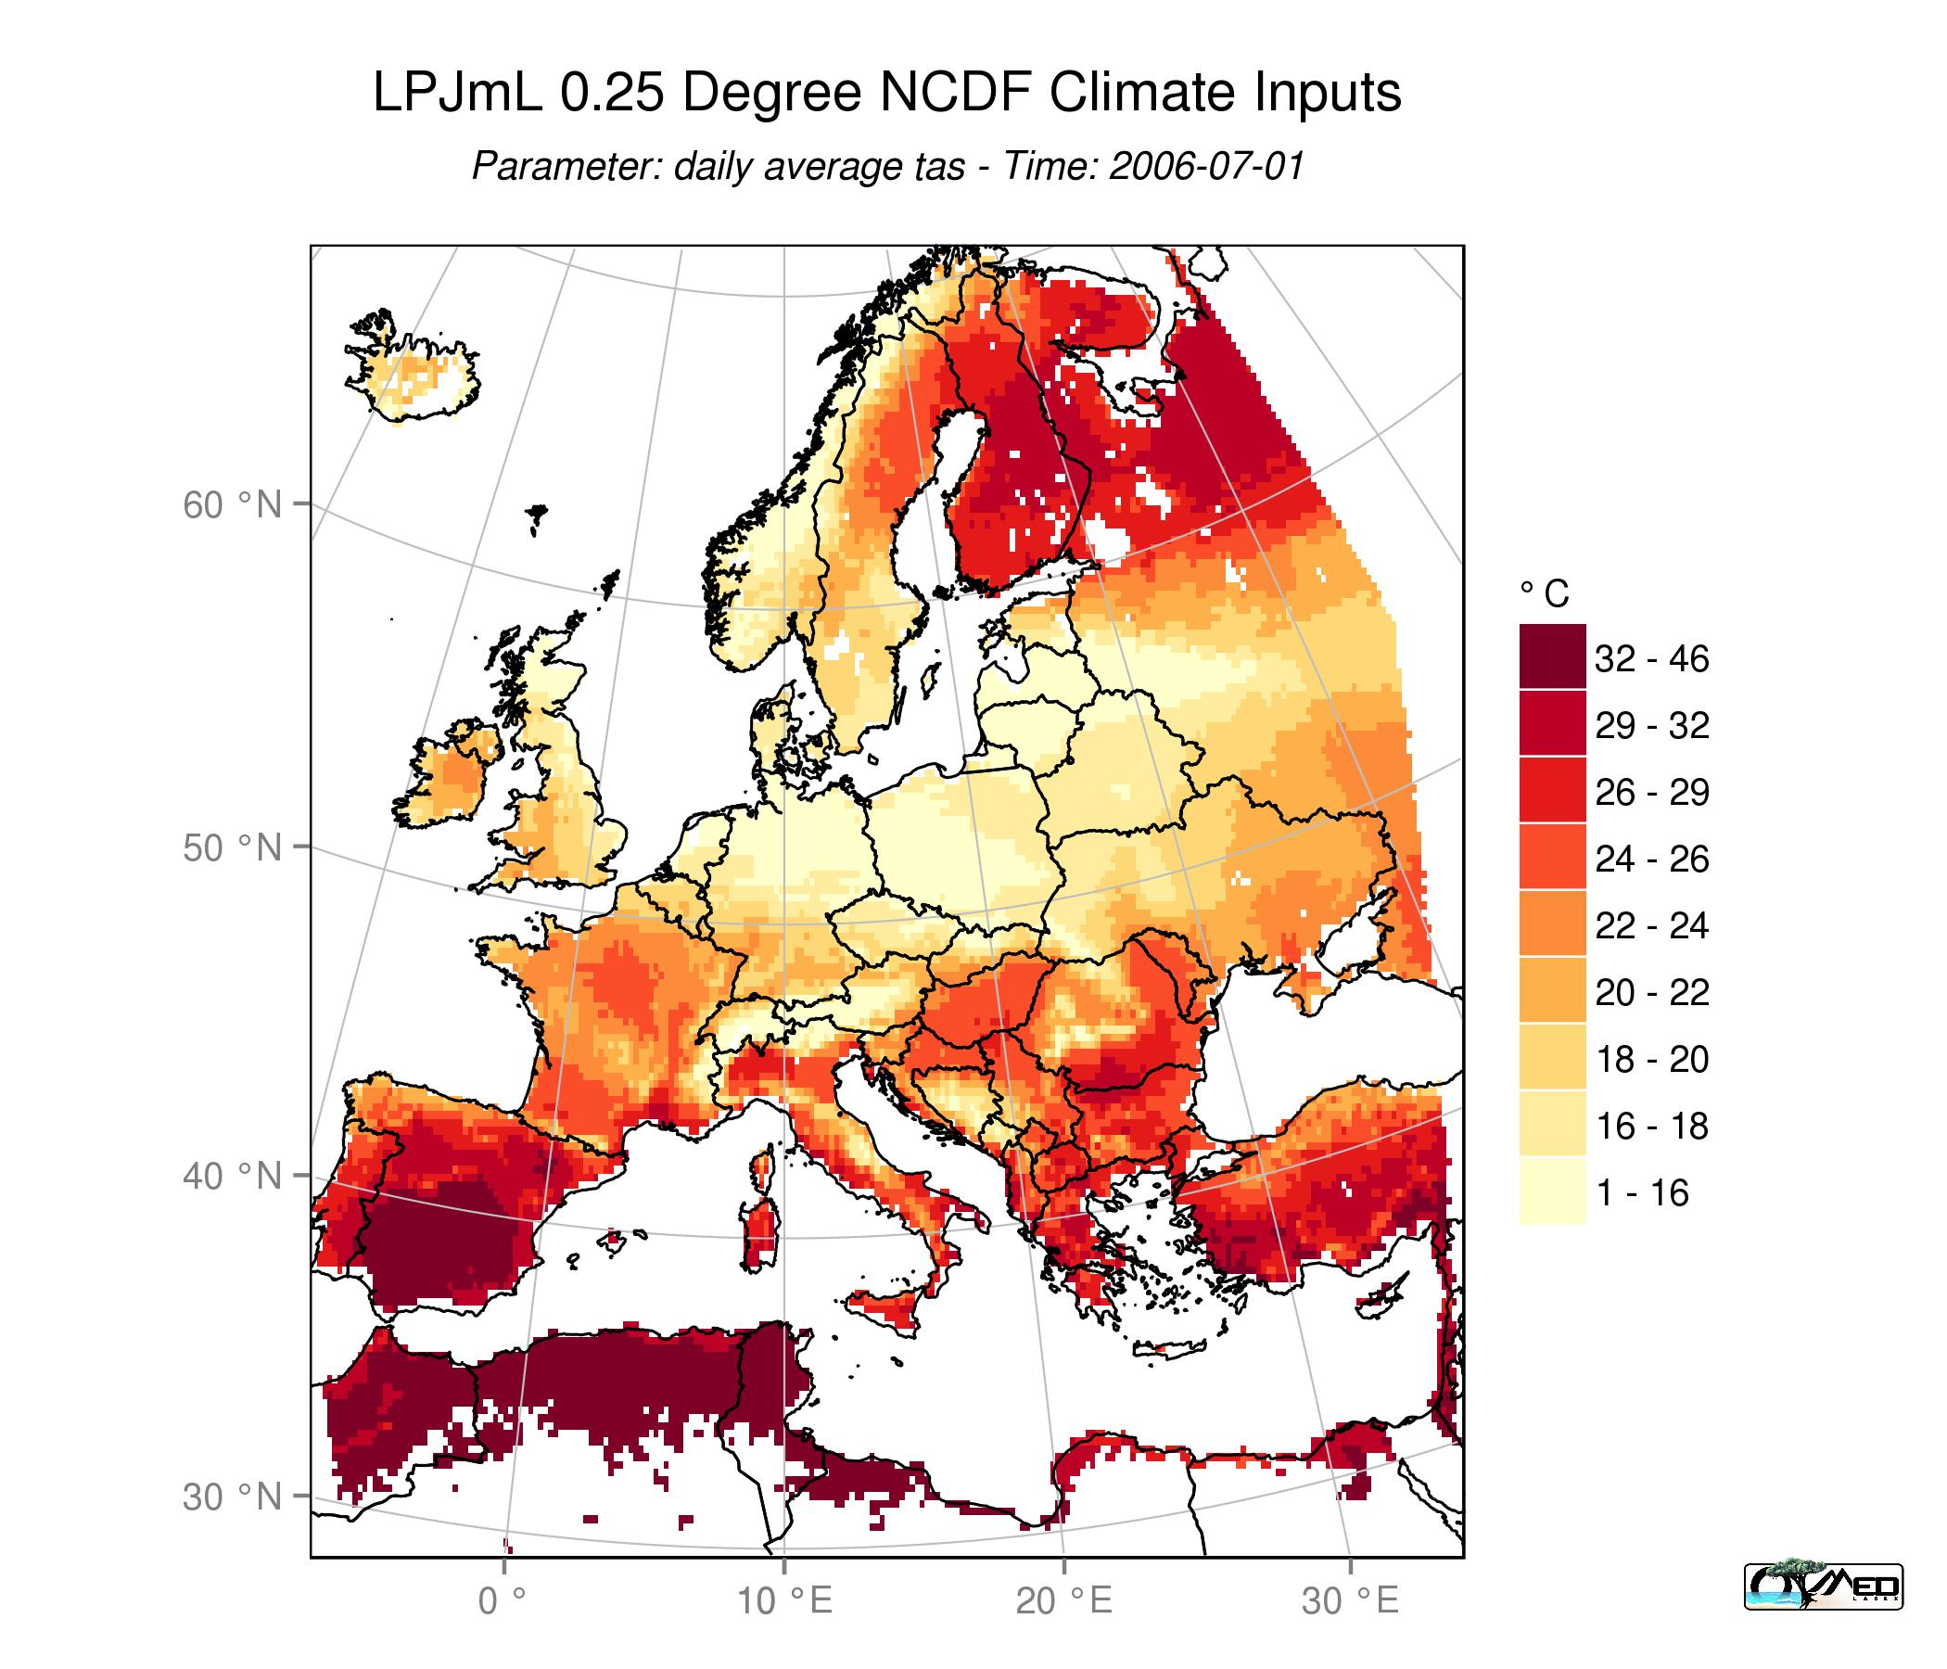
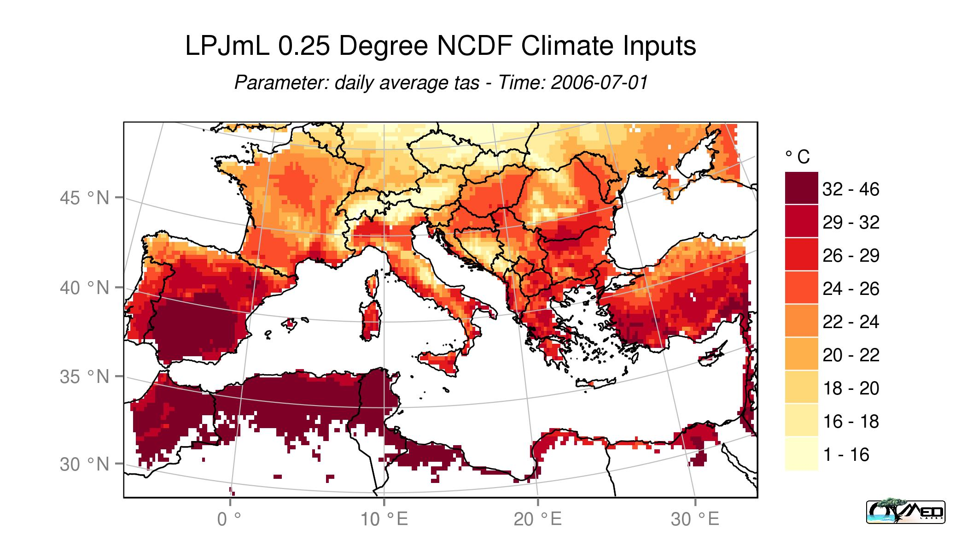
- Display maps as classes rather than gradient to have a better visual appearance
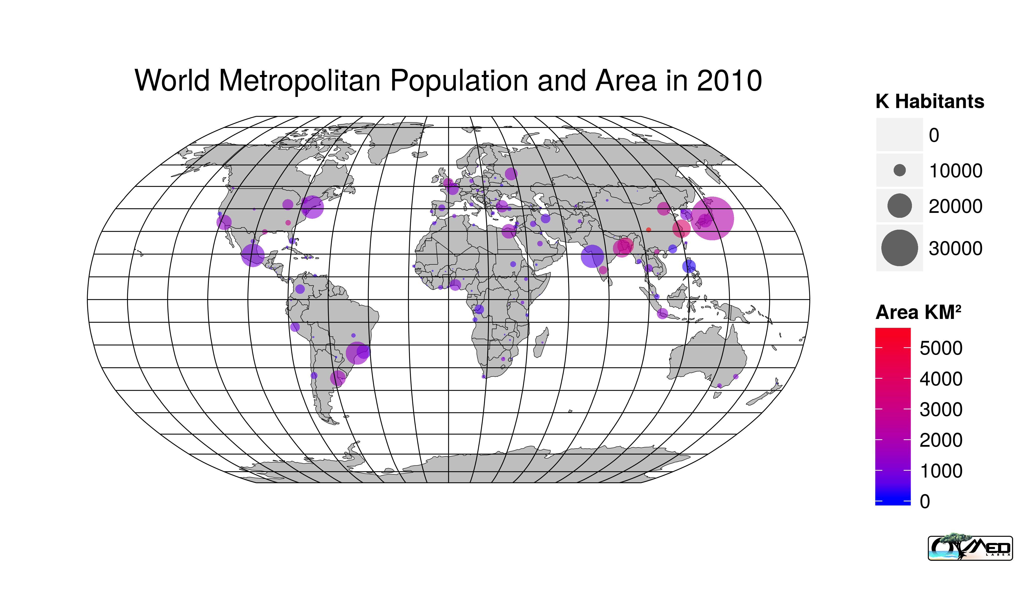
- Visualise attribute tables from polygons and points.

